Movies Dashboard Analysis For Business Growth And Decision-Making

**1. Business Understanding**

The dashboard appears to analyze the financial and performance metrics of movies, focusing on Return on Investment (ROI), marketing expenses, production factors, and the influence of variables like genre, 3D availability, and lead actress rating.

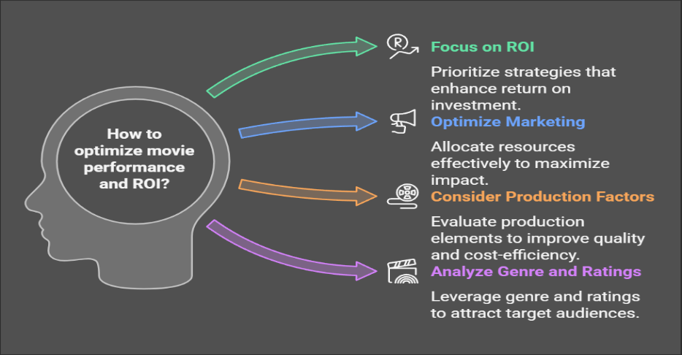

**2. Data Required**

To derive these insights, the data includes:

* **Financial Metrics**: Budget, collection, marketing expenses
* **Movie Characteristics**: Genre, 3D availability, movie length, trailer views
* **Casting Impact**: Lead actress rating, average age of actors
* **Performance Indicators**: ROI, revenue, trailer views

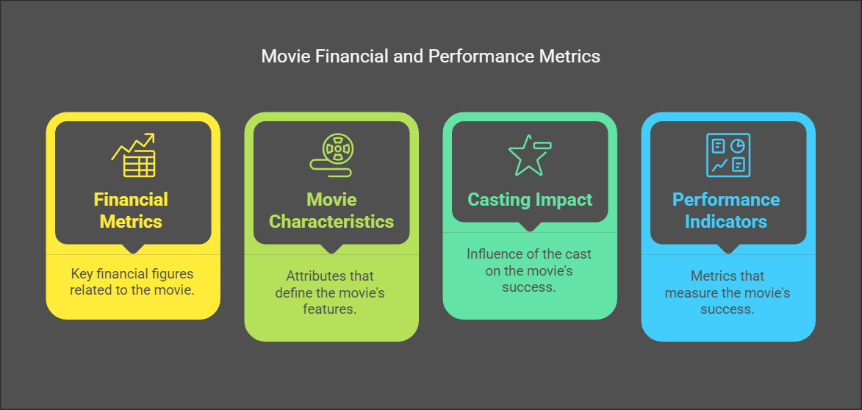

**3. Data Collection**

The data is likely sourced from box office reports, movie databases, and marketing campaign analytics.

**4. Data Validation & Understanding**

The data is validated through:

* Consistency checks (e.g., ROI calculation = (Collection - Budget) / Budget)
* Outlier detection (extreme budgets or revenues)
* Ensuring data accuracy across different variables
* 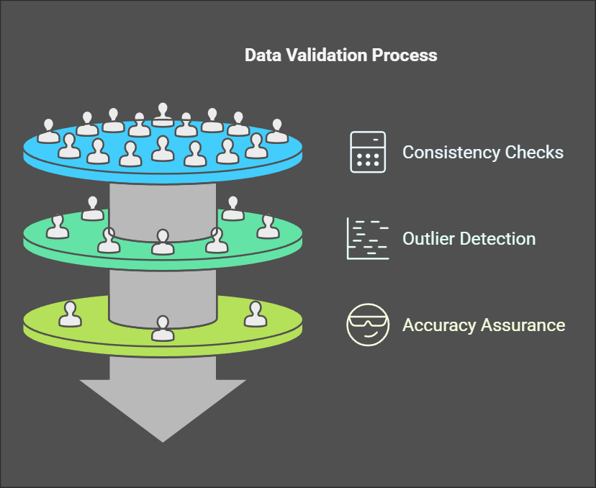

**5. Data Cleaning**

* Handling missing values (e.g., missing budget or ROI data)
* Removing duplicate entries
* Normalizing numerical values (e.g., budget and collections in the same unit)
* 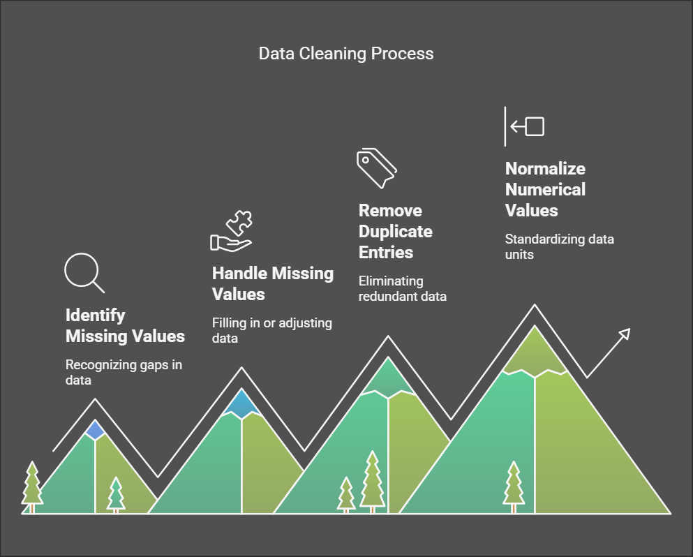

**6. Data Analysis Using Different Tools**

The dashboard visualizes relationships using:

* **Comparative Analysis**: Budget vs. Collection, ROI vs. Expenses
* **Category-based Analysis**: Genre influence on budget & revenue
* **Trend Analysis**: Trailer views vs. time taken

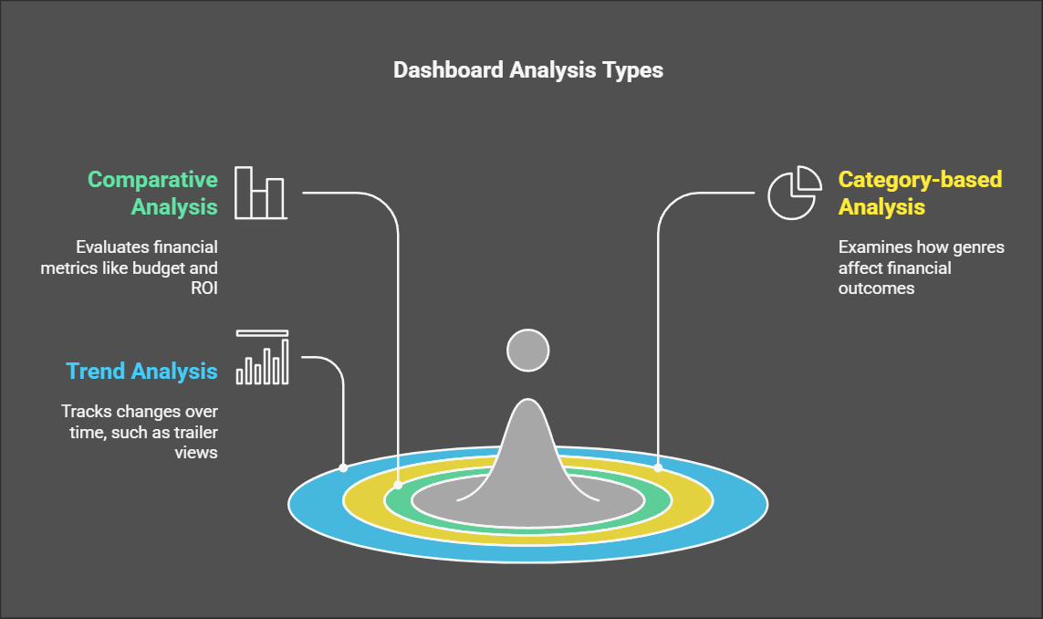

**7. Dashboard Preparation**

The dashboard is structured with key visuals:

* **ROI vs. Expenses Chart**: Shows profitability trends
* **Genre vs. Budget & Collection**: Analyzes the impact of genre choice
* **3D vs. ROI & Actor Age**: Explores technological & cast impacts
* **Lead Actress Rating vs. Marketing Expense**: Examines star power influence
* **Budget vs. Collection Chart**: Assesses financial success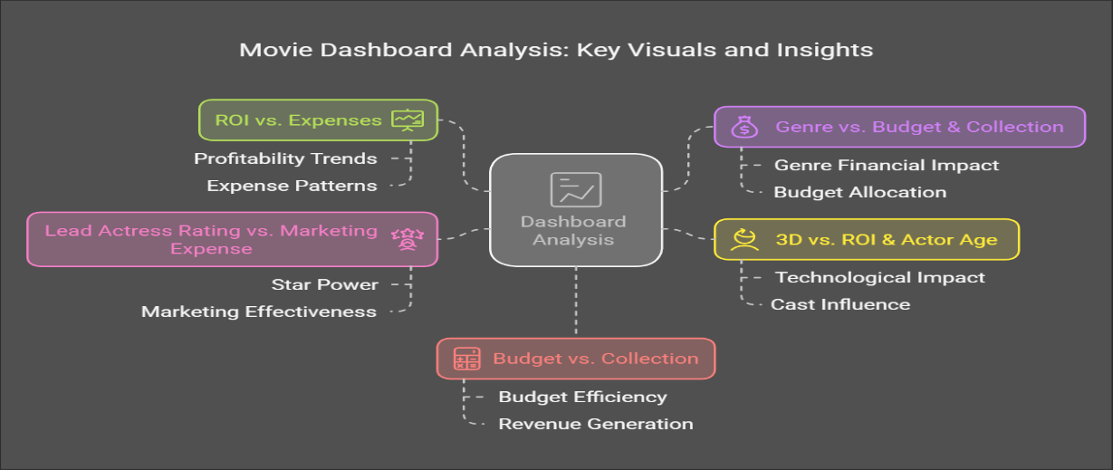

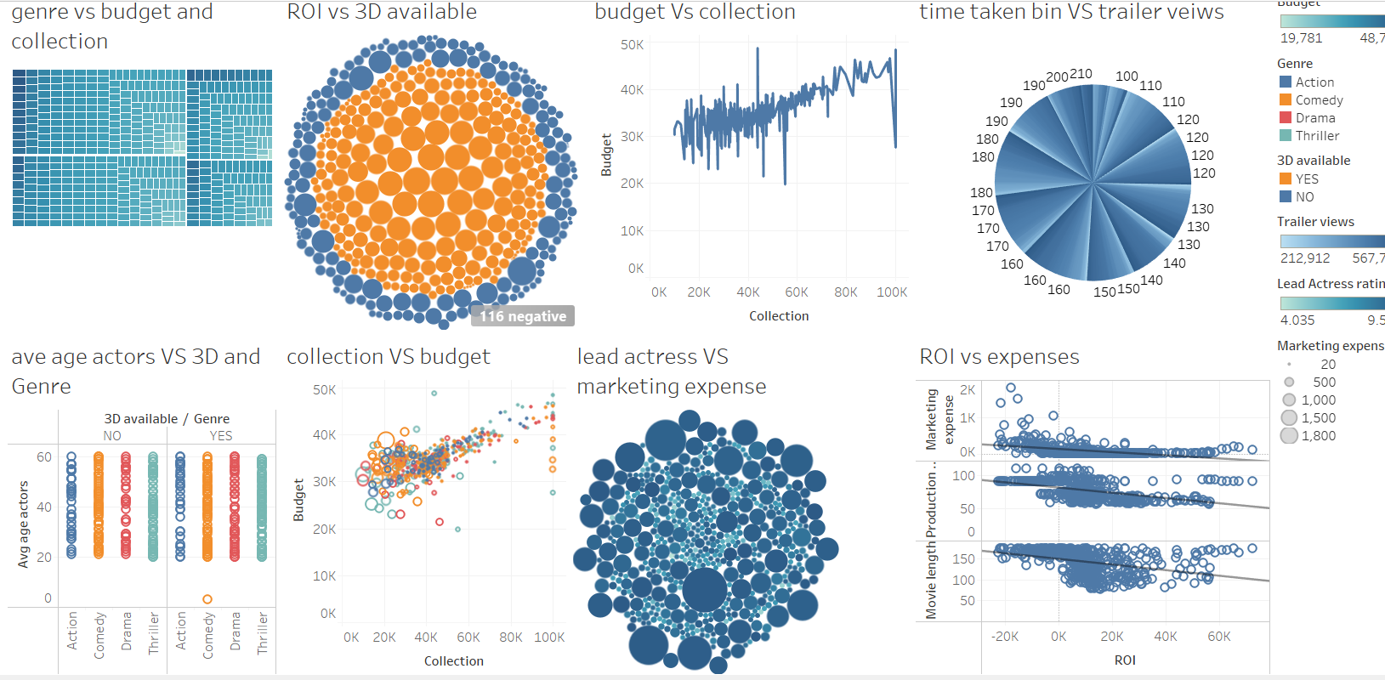

**8. Meaningful Insights**

* **Higher Budget ≠ Higher ROI**: Some high-budget films have low returns.
* **Marketing Expense Impact**: Higher marketing spend tends to correlate with better collections.
* **3D Availability & ROI**: Movies with 3D seem to have better ROI.
* **Genre Influence**: Action and Thriller genres have higher budgets and collections.
* **Actor Age Factor**: Younger actors are more common in high-earning movies.
* **Trailer Views & Success**: Higher trailer views may indicate better performance.

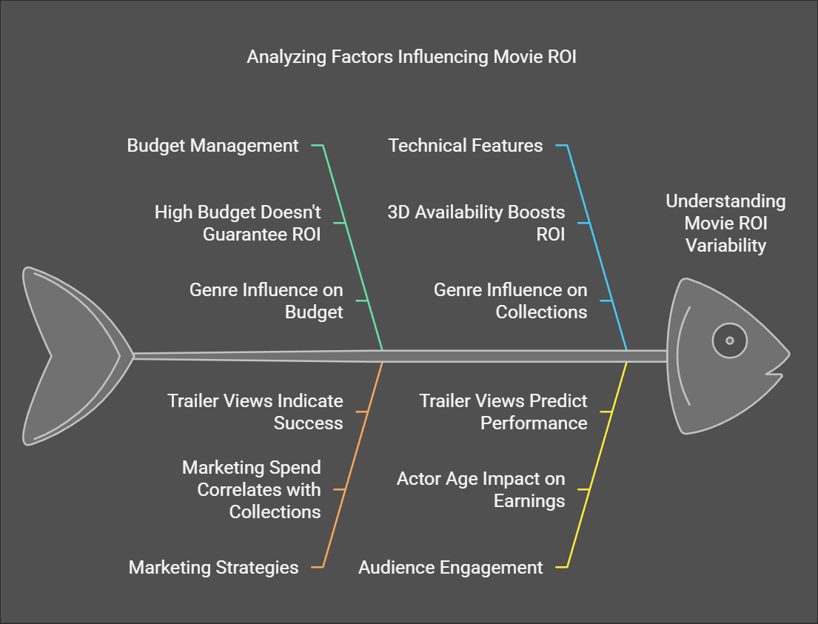

**9. Decision & Business Growth**

* **Optimize Budgeting**: Invest in profitable genres (Action, Thriller).
* **Strategic Marketing**: Increase marketing for high-potential films.
* **Leverage 3D Technology**: If feasible, 3D can enhance revenue.
* **Target Younger Lead Actors**: Their presence may increase audience appeal.
* **Improve Trailer Strategies**: Engage audiences earlier for better collections.

